**Task: create a checklist for ‘Add User’ and ‘Add Address’ pages using test design techniques. Separate scenarios by test design techniques.**

1. **Equivalence class & Boundary Value checklist:**

| **ID** | **Site:**[**https://traineeautomation.azurewebsites.net/**](https://traineeautomation.azurewebsites.net/) | **Result** | **Input Data** | **Result** |
| --- | --- | --- | --- | --- |
| **Add User** | | | | |
| AU1 | Equivalence class & Boundary Value. Add user with valid data  (**User Name** - 3,4, 13,14 letters ;  **Year of Birth** - 4 numbers) | Passed | **User Name** - Olh, Olha OlhaMorhunolha  **Year of Birth** - 1996 | The user is added and displayed on the main page. |
| AU2 | Equivalence class & Boundary Value. Check adding user with not valid data  (**User Name** - empty,2, 15 letters, numbers, special characters; **Year of Birth** - letters, empty, 3,5 numbers, negative value) | Failed | **User Name** - empty, Ol, OlhaMorhunolhao,1@!  **Year of Birth** - qwer, 199, 19966, -1 | The user is added after entering numbers and special symbols in User Name |
| **Add Address** | | | | |
| AD1 | Equivalence class & Boundary Value. Add address with valid data  (**Street Address** - 5, 6, 29, 30 letters with numbers, **City and State** - 5, 6, 14, 15 letters, **Zip Code** - 5 numbers) | Passed | **Street Address** - Knyaz, Knyazy, Knyazya Konstantina Ostrozkog, Knyazya Konstantina Ostrozko 1  **City**- Dnipr, Dnipro, Kamianets Podi, Kamianets Podil  **State** - Dnipr, Dnipro, Dnipropetrovsk, Dniepropetrovsk  **Zip Code** - 71601 | The address is added and displayed on the main page. |
| AD2 | Equivalence class & Boundary Value. Add address with not valid data  (**Street Address** - 4, 31, numbers ans special symbols, **City and State** -4, 16 letters, **Zip Code** - 4, 6 numbers, letters, special symbols) |  | **Street Address** - Knya, Knyazya Konstantina Ostrozkog 1, 1@#2  **City**- Dnip, Kamianets Podilla  **State** - Dnip, Dnipropetrovskiy  **Zip Code** - 7160, 716000, qwert, @#$%$ | The address is not added |

**2. Pairwise testing:**

1. **Add user - instead of 35 only 22 tests** 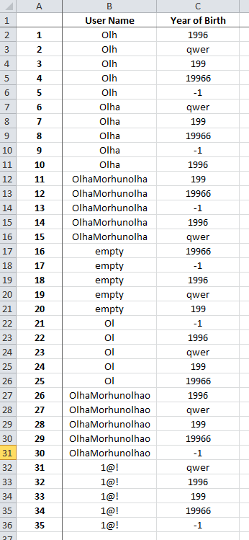

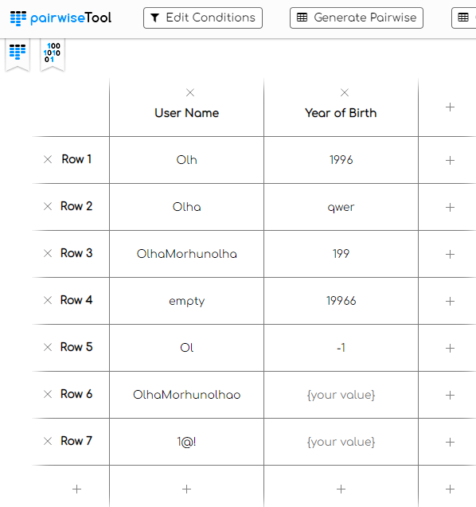

1. **Add address - only 46 tests instead of 1260:**

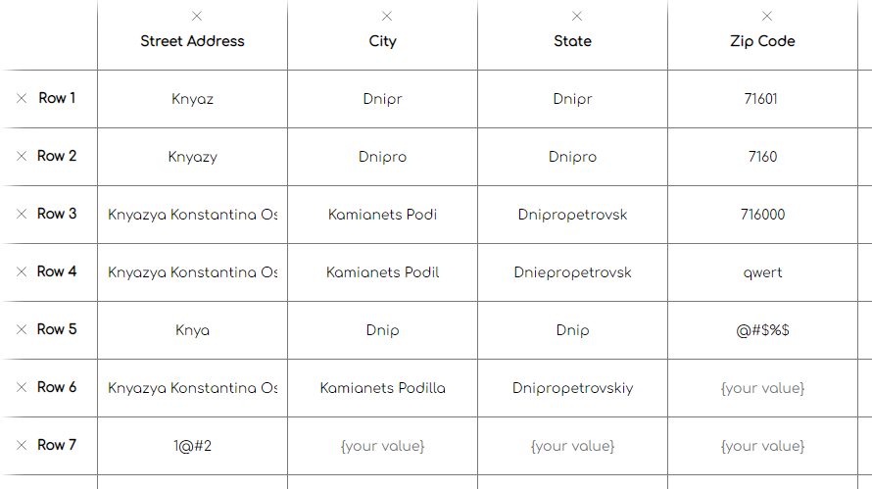

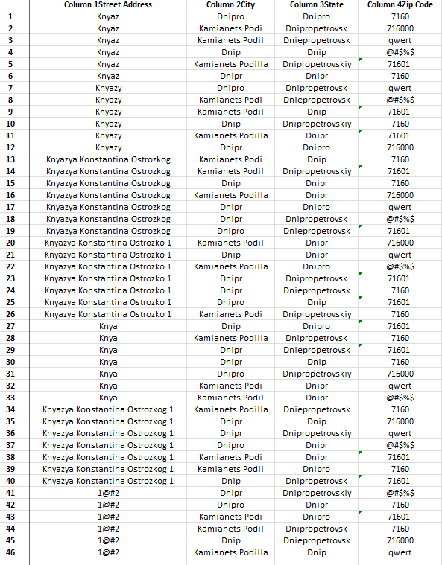

**3. Decision table**

1. **Adding of User**

| **Condition** | **Case 1** | **Case 2** | **Case 3** | **Case 4** |
| --- | --- | --- | --- | --- |
| User Name | 0 | 0 | 1 | 1 |
| Year of Birth | 0 | 1 | 0 | 1 |
| User is added | F | F | F | T |

1. **Adding of Address**

| **Condition** | **1** | **2** | **3** | **4** | **5** | **6** | **7** | **8** | **9** | **10** | **11** | **12** | **13** | **14** | **15** | **16** |
| --- | --- | --- | --- | --- | --- | --- | --- | --- | --- | --- | --- | --- | --- | --- | --- | --- |
| Street Address | 0 | 0 | 0 | 0 | 0 | 0 | 0 | 0 | 1 | 1 | 1 | 1 | 1 | 1 | 1 | 1 |
| City | 0 | 0 | 0 | 0 | 1 | 1 | 1 | 1 | 0 | 0 | 0 | 0 | 1 | 1 | 1 | 1 |
| State | 0 | 0 | 1 | 1 | 0 | 0 | 1 | 1 | 0 | 0 | 1 | 1 | 0 | 0 | 1 | 1 |
| Zip Code | 0 | 1 | 0 | 1 | 0 | 1 | 0 | 1 | 0 | 1 | 0 | 1 | 0 | 1 | 0 | 1 |
| Address is added | F | F | F | F | F | F | F | F | F | F | F | F | F | F | F | T |

**4. State transition diagram**



**5. Use Case**

| **Add User, Add Address** | |
| --- | --- |
| **Description** | User has possibility to add User and Address on the site |
| **Actor** | Unauthorized user |
| **Actions** | |
| **Basic flow** | 1. User can ‘Edit' or ‘Delete’ the User on the main page for updating or deleting the data.  2.User can ‘Edit' or ‘Delete’ the Address on the main page for updating or deleting the data. |
| **Exception flow** | User enters not valid data in the text areas of the form and clicks the 'Create’ button - error messages appear near the filed form. Not able to create a new User/Address with not valid data. |

**6. Exhaustive testing** is possible only for Add User - 35 use cases, but for Add Address - 1260 use cases, only for Automated testing.